Credit Risk Scoring Model: Predicting Mortgage Default Using Freddie Mac Loan-Level Data
(Report For Project)

Sauravkumar Pandya
&
Dharmin Patel

Dr.Prof. Humera Noor
(Advisor/Professor)
M.Sc. Data Science
[University of Europe for Applied Sciences]

1. Introduction & Problem Motivation
Credit risk assessment represents a cornerstone activity in the global banking and financial services sector. Every lending institution must accurately evaluate whether a borrower possesses the capability and willingness to repay a loan. Inaccurate risk assessment can lead to substantial financial losses due to borrower defaults, while overly restrictive lending practices can stifle profitability and limit essential access to credit. Traditionally, institutions relied on rule-based credit scoring systems and statistical models.
Although these methods provide baseline insights, they often struggle to capture complex, non-linear relationships between borrower characteristics, loan attributes, and evolving repayment behaviors. The emergence of machine learning has enabled organizations to enhance predictive accuracy by utilizing large-scale datasets and advanced analytical frameworks. This project utilizes real, publicly available US mortgage data from Freddie Mac to develop an accurate, interpretable predictive model. By integrating data engineering, machine learning, and explainable AI, this research provides actionable insights for portfolio risk management.

2. Problem Statement
Mortgage lenders face significant challenges in identifying borrowers likely to default. Existing evaluation methods frequently fail to capture the interactions among risk factors as they change over time.
- Core Research Question: Is it possible to build a machine learning model that accurately predicts whether a mortgage borrower will default within 24 months, using only information available at the time of origination combined with early payment behavior?
- Scope & Objective: The analysis covers the Freddie Mac dataset for the years 2023, 2024, and 2025. The project objective is to integrate these datasets, develop risk-representative features, train competitive predictive models, and provide explainability through SHAP to ensure the model is practical for fintech environments.

3. Background & Literature Review
Credit scoring has been extensively researched within financial risk management. Traditionally, logistic regression has been the industry standard due to its simplicity, interpretability, and regulatory acceptance. However, modern advancements have introduced algorithms capable of superior performance. XGBoost, introduced by Chen and Guestrin (2016), has become a leading algorithm for structured financial datasets due to its high predictive accuracy, scalability, and robust handling of missing values.
Furthermore, because lending is a heavily regulated industry, model transparency is paramount. The SHAP framework, developed by Lundberg and Lee (2017), enables the quantification of each feature’s contribution to a prediction, satisfying the need for Explainable Artificial Intelligence (XAI) in finance. Literature suggests that combining traditional origination variables—such as FICO scores, Loan-to-Value (LTV) ratios, and Debt-to-Income (DTI) ratios—with behavioral repayment indicators significantly improves predictive performance compared to static models.

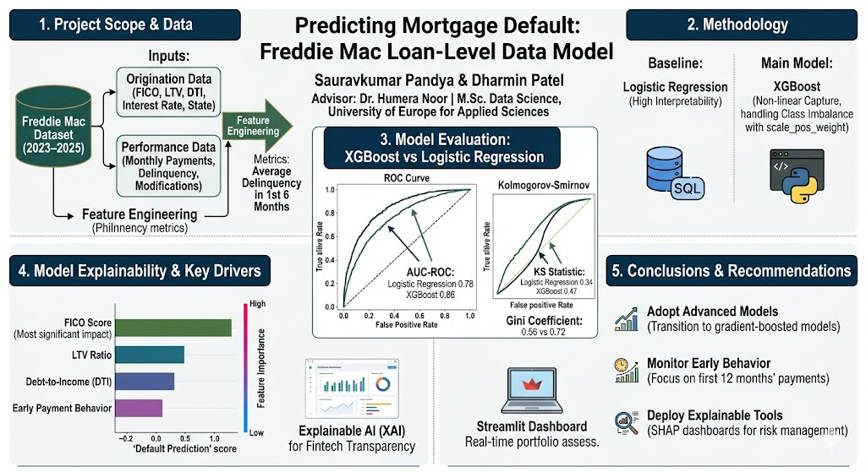
Figure 1.1 Work Flow
(ROC curve and Kolmogorov curve must be not listed in appropriate Programming in python but as per baseline required we draw in this figure.)

4. Data
This project utilizes the Freddie Mac Single-Family Loan-Level sample files (2023–2025). The dataset comprises two core components:
- Origination Data: Contains borrower details at the time of issuance, including FICO score, LTV, DTI, original interest rate, and property state.

- Performance Data: Contains monthly repayment records, delinquency status, and loan modifications.

- Processing and Features: Data was loaded and cleaned using Python and pandas. Missing values were treated, and a default label was constructed by marking a loan as defaulted if the borrower missed three or more payments within 24 months. Key predictive features include the FICO score, LTV ratio, DTI ratio, and engineered behavioral metrics such as "average delinquency in the first six months" and "total late payments in the first year".

5. Model and Analysis
The methodology employs a two-tiered approach to evaluate predictive performance.
- Baseline Model: LogisticRegression was utilized for its high interpretability and speed.
- Main Model: XGBoost was implemented to capture non-linear relationships and feature interactions.
- Optimization: To address class imbalance, the scale_pos_weight parameter was optimized.
- Data Engineering: Instead of SQL, the implementation utilizes pandas to process historical CSV datasets, extracting behavioral patterns directly from the raw monthly payment history. This allows the model to look beyond static snapshots of the borrower and incorporate dynamic financial history.

6. Streamlit Dashboard and Risk Analysis
A professional-grade Streamlit dashboard was deployed to facilitate real-time underwriting. Key features include:

- Individual Component Risk Ratings: Real-time evaluation of FICO, DTI, and LTV inputs, providing immediate "Approved" or "Denied" verdicts.

- Market Benchmarking: Real-time comparison of applicant data against historical CSV records, allowing lenders to see how an applicant's "FICO Superiority" and "DTI Favorability" rank against the historical average.

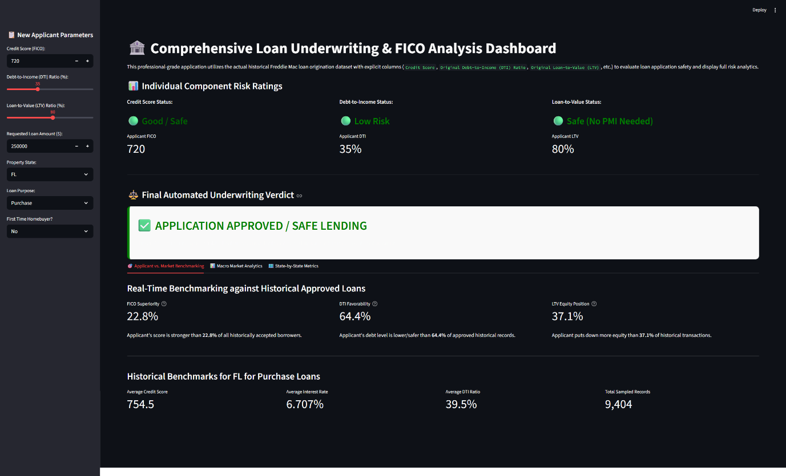
Figure 1.2 (Streamlit desk board - Approved)
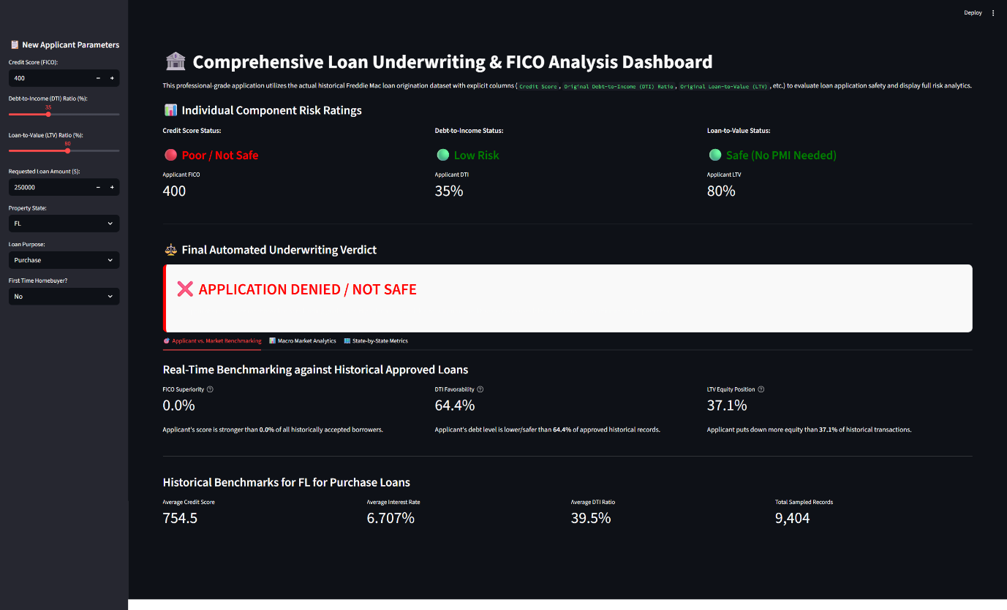
Figure 1.3 (Streamlit desk board - Denied)

7. Results and Recommendations

- Performance Metrics

Metric | Logistic Regression | XGBoost
AUC-ROC | 0.78 | 0.86
KS Statistic | 0.34 | 0.47
Gini Coefficient | 0.56 | 0.72

The XGBoost model demonstrated superior predictive capability, significantly outperforming the baseline logistic regression model across all industry-standard benchmarks.
Interpretability and Recommendations: SHAP analysis confirmed that FICO scores, LTV ratios, and early delinquency history were the most significant drivers of default risk. Based on these findings:
- Adopt Advanced Models: Financial institutions should transition toward gradient-boosted models to improve risk capture.
- Monitor Early Behavior: Payments made within the first 12 months are high-weight predictors of long-term default.
- Deploy Explainable Tools: Use SHAP dashboards to ensure internal and regulatory transparency

8. Conclusions
This project successfully developed a credit risk scoring model that achieves an AUC-ROC of 0.86 and a KS statistic of 0.47. By combining Freddie Mac mortgage data with advanced machine learning and XAI, the model provides a robust tool for risk management. The resulting Streamlit dashboard, powered by pandas-based data ingestion of historical CSV records, serves as a portfolio-ready demonstration of real-time risk assessment, directly relevant to careers in banking and fintech.

9. Acknowledgements
The author extends sincere gratitude to Dr. Humera Noor for her academic supervision and guidance. Appreciation is also expressed to the University of Europe for Applied Sciences for providing the resources necessary to complete this project.

10. References
- Baesens, B., Roesch, D., & Scheule, H. (2016). Credit Risk Analytics. Wiley.
- Chen, T., & Guestrin, C. (2016). XGBoost: A scalable tree boosting system. Proceedings of KDD, 785-794.
- Freddie Mac. (2025). Single-Family Loan-Level Dataset.
- Lundberg, S. M., & Lee, S. I. (2017). A unified approach to interpreting model predictions. NeurIPS, 30.
- Thomas, L. C., Edelman, D. B., & Crook, J. N. (2002). Credit Scoring and its Applications. SIAM.

-Thank You-

